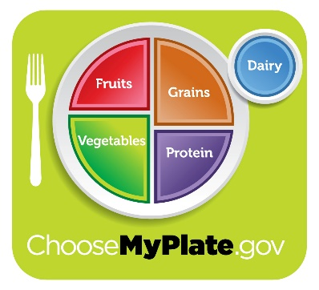
Choosing a variety of foods from each food group will provide a healthy, well-balanced diet.
Healthy choices are marked with and contain low amounts of added sugar, sodium, and saturated fat. Make sure to stock up on these items first!
SHOPPING LIST

Please select the indicated number of items from each of the categories below. If you would like more than one of an item please write the amount you would like next to the item.

FRUIT
Limit 2 choices per household. You may choose more than one of each.
- Applesauce, unsweetened
- Bananas
- Dried plums
- Mandarin oranges canned in 100% juice
- Orange juice, 100% juice
- Red apples
- Strawberries
VEGETABLES
Limit 3 choices per household. You may choose more than one of each.
- Bell peppers
- Cabbage
- Canned corn, no salt added
- Canned mixed vegetables, no salt added
- Carrots
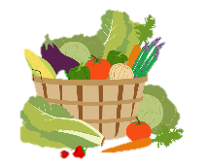
- Cucumbers
- Lettuce
- Onions
- Potatoes
- Tomatoes

RECIPES TO TRY:
- OATMEAL BITES: Bananas + Peanut butter + Rolled oats
- PASTA: Fettucine + Spaghetti sauce + Canned mixed vegetables
- FAJITAS: Bell peppers + Onion + Chicken thighs + Tortillas

PROTEINS
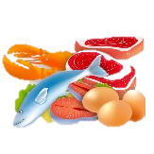
Limit 2 choices per household.
- Ground beef
- Pork loin
- Chicken thighs
- Canned chicken breast
- Canned tuna
- Canned pink salmon
- Peanut butter
- Split peas
- Dark red kidney beans
- Garbanzo beans

DAIRY
Limit 2 choices per household.
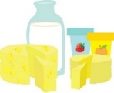
- Shredded cheddar
- Block cheddar
- Sour cream
- Low-fat yogurt, no added sugar
- 1 % milk
- Dehydrated low-fat milk

EXTRAS
Limit 1 of each per household.
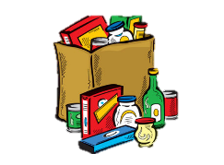
- Bag of candy
- Pastry or other dessert

- SALAD: Lettuce + Tomatoes + Canned salmon or tuna + Salad dressing
- STIR FRY: Carrots + Bell pepper + Tofu + Brown rice
- CORN SALSA: Canned corn + Kidney beans + Tortilla chips

GRAINS
Limit 1 bread choice per household plus 1 other choice.
- 100% Whole wheat
bread
- Fettucine pasta
- Brown rice, 100% whole
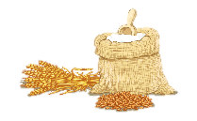
grain
- Rolled oats

PANTRY & CANNED GOODS
Limit 6 choices per household. You may choose more than one of each.
- Baked beans
- Boxed dinner
- Canned chili
- Chicken broth
- Crackers
- Cream of mushroom
- Frozen meal
- Salad dressing
- Spaghetti sauce
- Tortilla chips
- Vegetable oil
- 6-pack flavored seltzer water

Source:www.foodgatherers.org

